Phase III: Image Search and Detection

Group 3:

Cody Ambrose, Rodney French, John Kaiser, Orry Newell

University of Maryland Global Campus

Revision: 1.2

Date: 12/8/2020

Class #: CMSC 495

**Revision Log**

|  |  |  |  |
| --- | --- | --- | --- |
| **Rev** | **Date** | **Editor** | **Description** |
| 1 | 12/3/2020 | Cody Ambrose | Original Document |
| 2 | 12/8/2020 | Cody Ambrose | Updates to Documentation |
|  |  |  |  |
|  |  |  |  |
|  |  |  |  |
|  |  |  |  |
|  |  |  |  |
|  |  |  |  |
|  |  |  |  |
|  |  |  |  |
|  |  |  |  |
|  |  |  |  |
|  |  |  |  |

# User’s Guide

## Phase3_Waldo.py

1. Download the Group3_Phase3.zip folder.

2. Unzip/Extract the contents of Group3_Phase3.zip folder.

3. From Spyder IDE 4.1.4 using Python 3.8.3, open Phase3_Waldo.py.

4. Click the green “Run file” arrow in the tool bar.

5. A GUI should appear (you may need to click over to it in your task bar).

6. Select the “Where’s Waldo” button.

7. The GUI will display a default scene (City) and target image (Waldo).

8. You may choose other scenes from the “Choose scene” dropdown and/or other target image characters from the “Choose character” dropdown.

9. Click the “Preview” button to display your chosen scene to search and target character to search for.

10. Click the “Search” button to initiate image detection for the character you chose.

11. The closest match to the character you chose will be highlighted in a green box within the scene and a zoomed in image of the character in the scene will be provided in the bottom right of the GUI.

12. You may choose other scenes and/or target image characters and repeat the “Preview” and “Search” process to attempt to find the chosen character in the chosen scene or close the application (two windows).

## 

*Note: The target images and “puzzle” images are included in the Group3_Phase3.zip folder at the appropriate file paths for Phase3_Waldo.py to find them. You must run Phase3_Waldo.py from the extracted location within the Group3_Phase3 folder to ensure images are properly pulled and referenced.

# Original Phase III Milestone

The original Phase III Milestone was to create a basic GUI with pre-determined images to locate Where’s Waldo characters within full-scale Where’s Waldo puzzles. This was to be accomplished using OpenCV within a Python programming environment. In addition, rescaling of the images and testing of different template matching techniques (i.e. scaling values, etc.) to better identify target images was to be performed in this phase. In addition, more characters were to be added as target images.

# Time Management/Schedule

Based on the results of Phase III testing, our group is on schedule according to our Phase III milestone. We have successfully developed a Python program, Phase3_Waldo.py, during Phase III that accomplished most of our goals and prompted additional research into methods and techniques. Furthermore, we identified three full-scale (one more than Phase II) Where’s Waldo puzzle images as input (City, Zoo, Ski Resort), as well as five target character images (instead of just Waldo in Phase II) we can use to find the Where’s Waldo characters (Waldo, Wenda, Wizard, Odlaw, Woof). The test matrix below shows the results of Phase III:

|  |  |  |  |
| --- | --- | --- | --- |
|  | **City** | **Zoo** | **Ski Resort** |
| **Waldo** | Found | Found | Not Found |
| **Wenda** | Found | Found | Found |
| **Wizard** | Found | Found | Found |
| **Odlaw** | Not Found | Found | Found |
| **Woof** | Not Found | Not Found | Not Found |

# Problems Encountered

We continued to explore additional methods within OpenCV to identify a target image within a given puzzle image. We found that template matching with adaptive gaussian thresholding (cv2.ADAPTIVE_THRESH_GAUSSIAN_C) still gave us the most accurate results. In addition, our multi-scaling approach from Phase II was carried over to Phase III. We experimented with different scaling values to hone the accuracy of finding Waldo and his friends.

# Reevaluation

Reflecting on the results of Phase III, we believe that our choice of Python and OpenCV is still the most appropriate solution for our larger “Where’s Waldo” project we are building towards. However, our results show that even with our fine tuning in Phase III, we did not achieve 100% accurate results. Additional research in edge detection and feature matching is necessary as we build towards more complex Where’s Waldo puzzles for Phase IV. We also believe that our choice of tkinter for the GUI interface, pathlib library for file paths (to standardize our data file structures across operating systems), input formats (.jpg, .jpeg, .png), output formats (.jpeg), test cases, and performance estimate benchmarks are all still appropriate to carry on to Phase IV.

# Results

## Phase3_Waldo.py

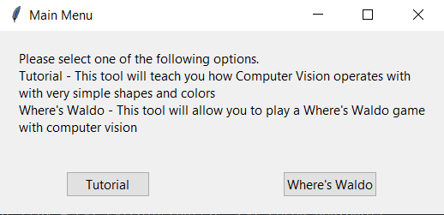

The initial GUI that launches when running Phase3_Waldo.py, click “Where’s Waldo”.

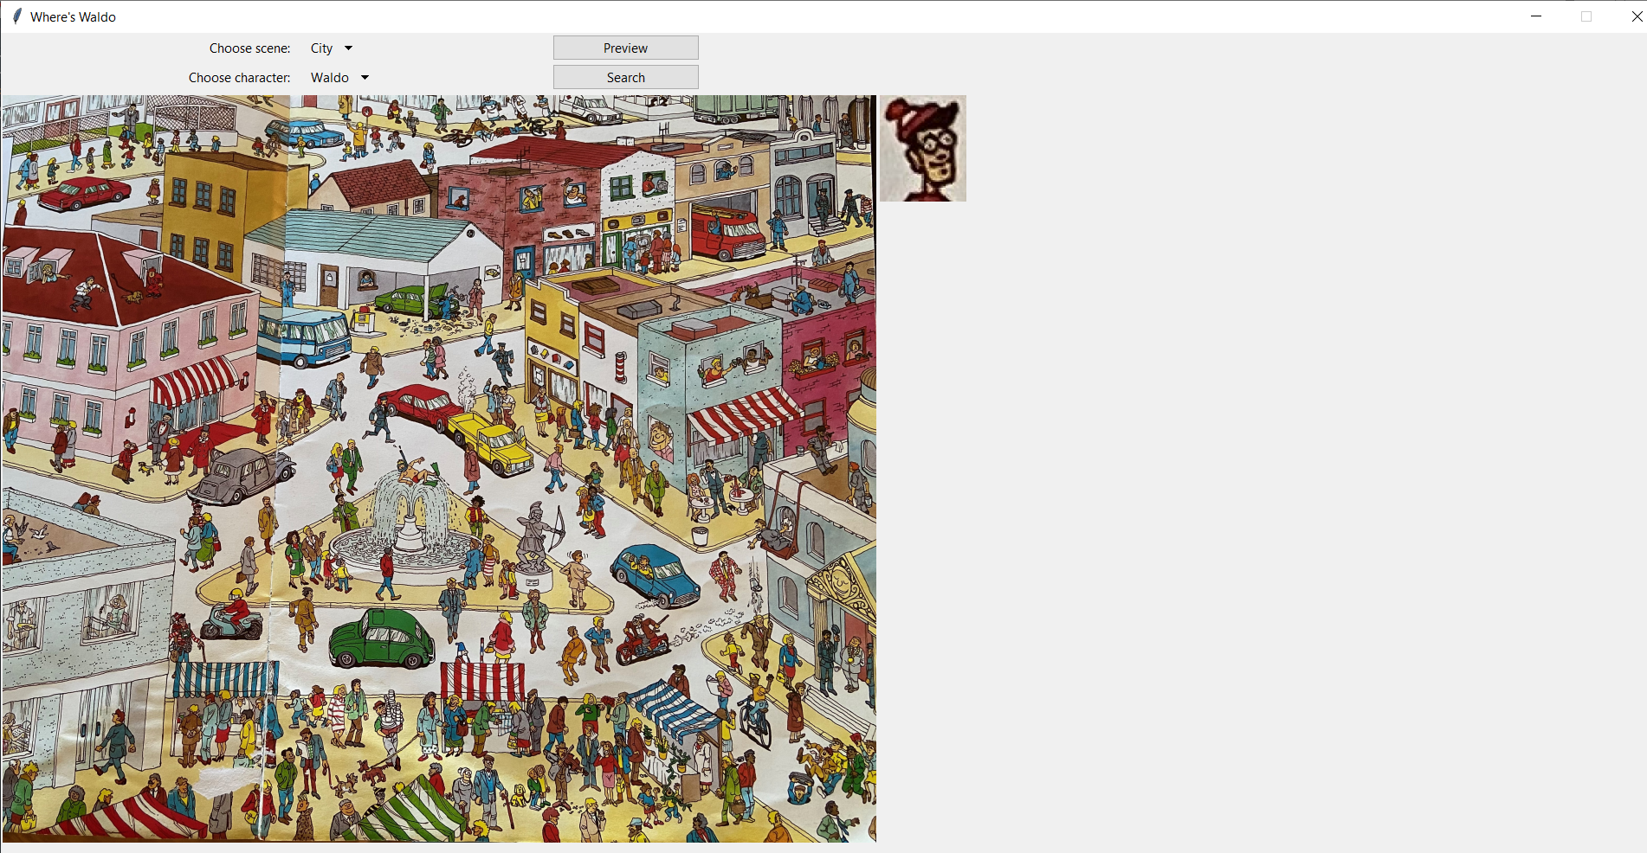

The GUI that is launched when the user clicks “Where’s Waldo”. A default scene (City) and default character to search for (Waldo) are displayed.

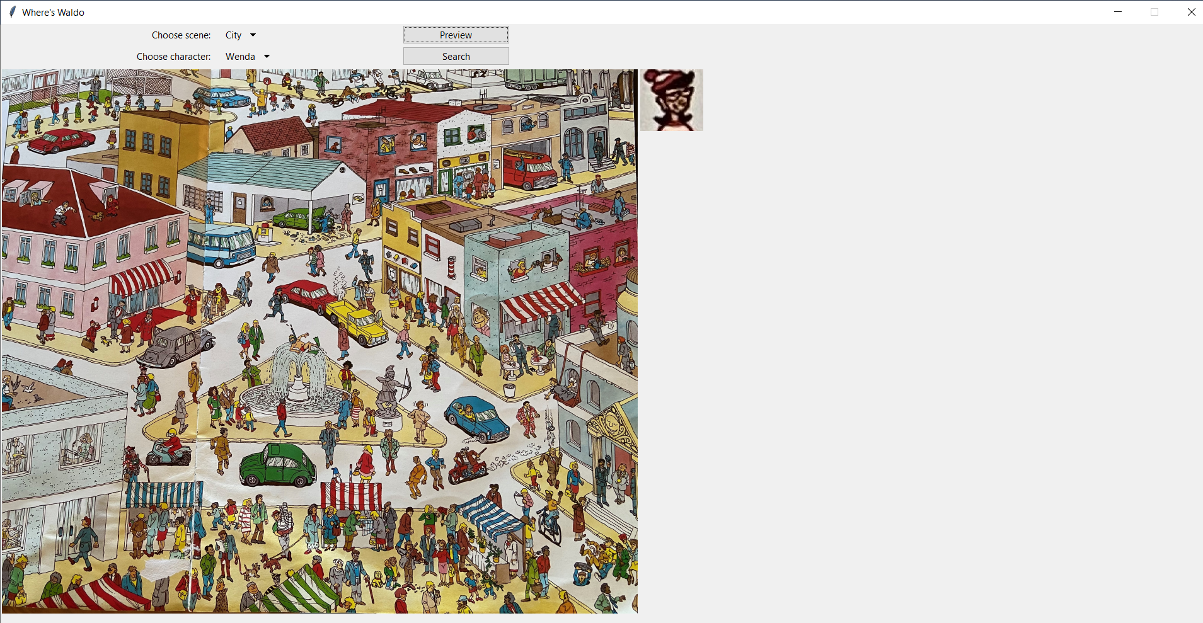

Keeping the same scene (City) and choosing a new character (Wenda), click “Preview” to get to the screenshot above.

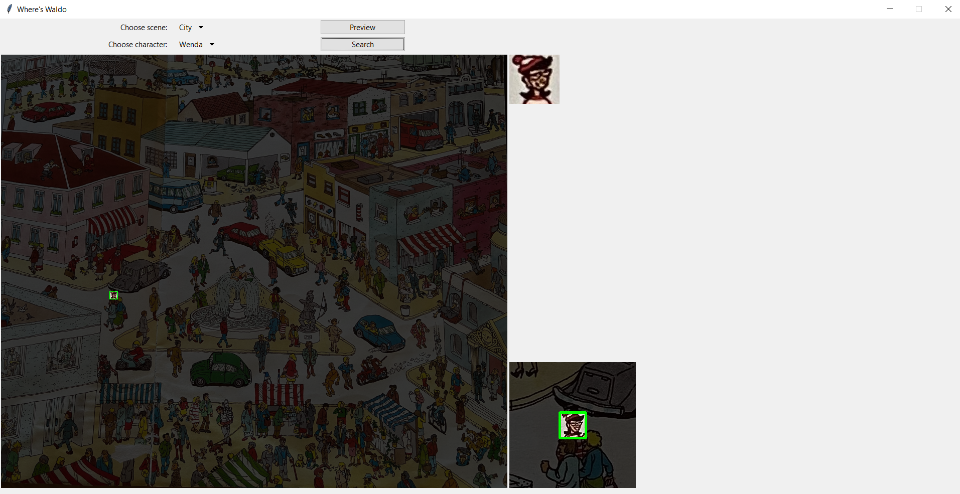

Clicking “Search” finds and outlines the chosen character (Wenda) in the chosen scene (City). Note that a zoomed in image of where Wenda was found appears in the bottom right of the GUI.

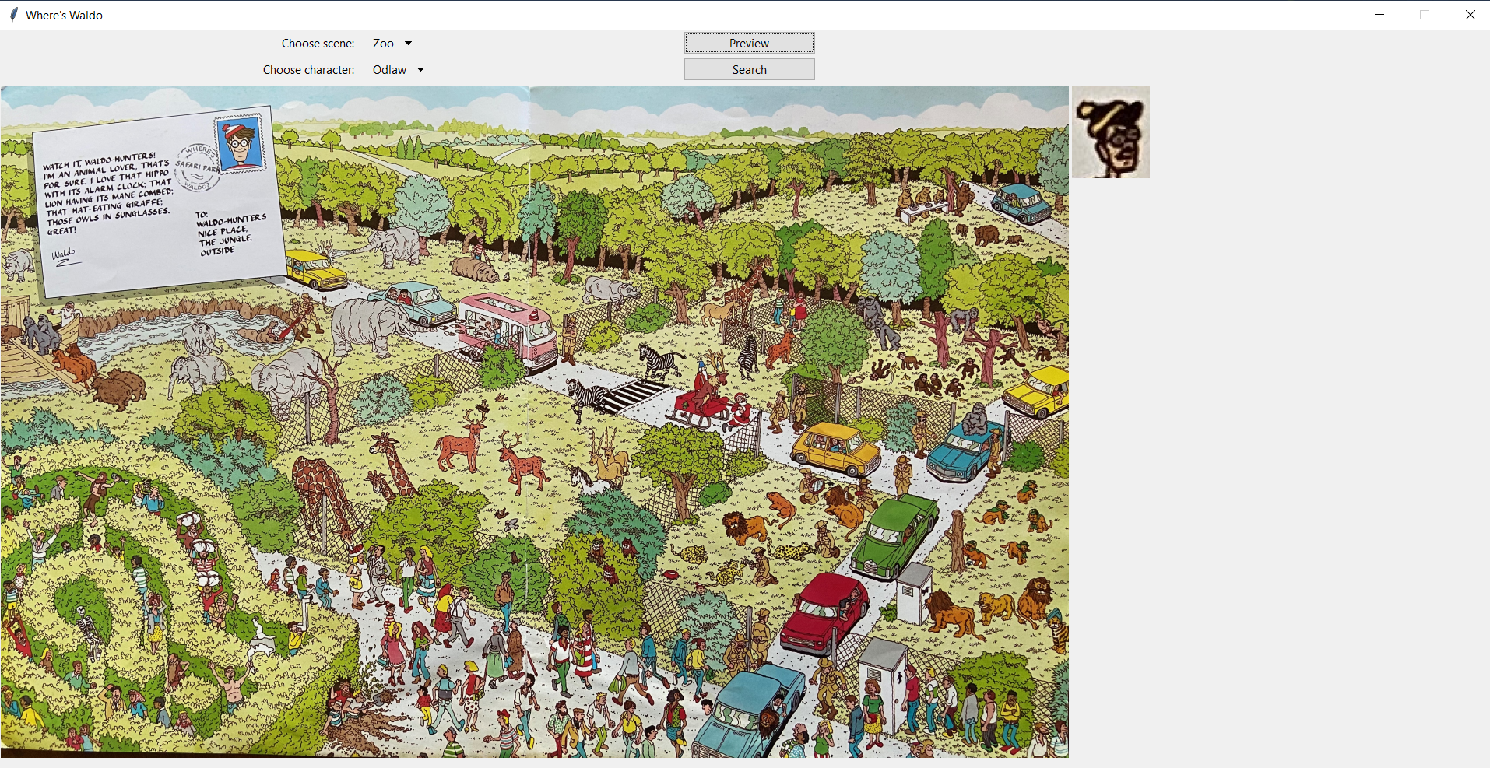

Choosing a new scene (Zoo) and a new character (Odlaw), click “Preview” to get to the screenshot above.

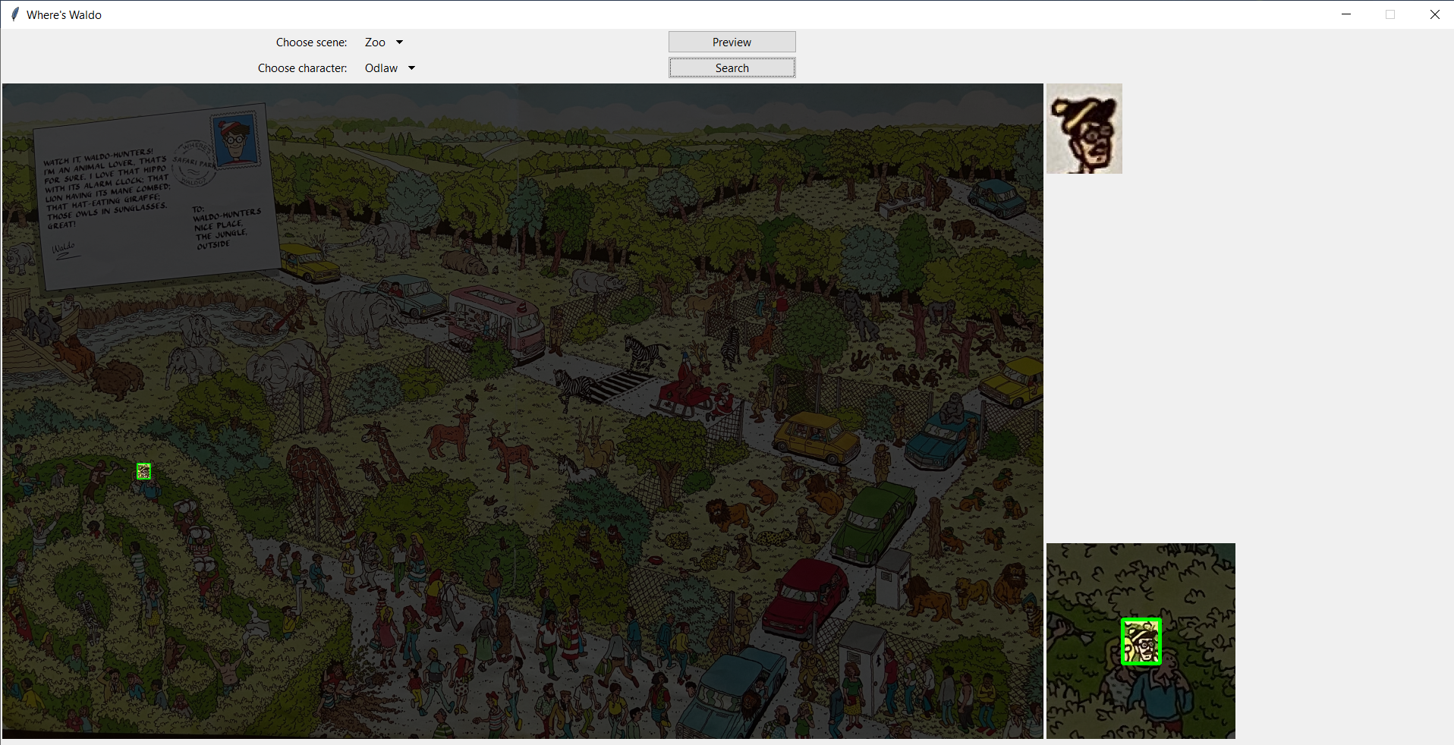

Click “Search” to find Odlaw in the Zoo scene.

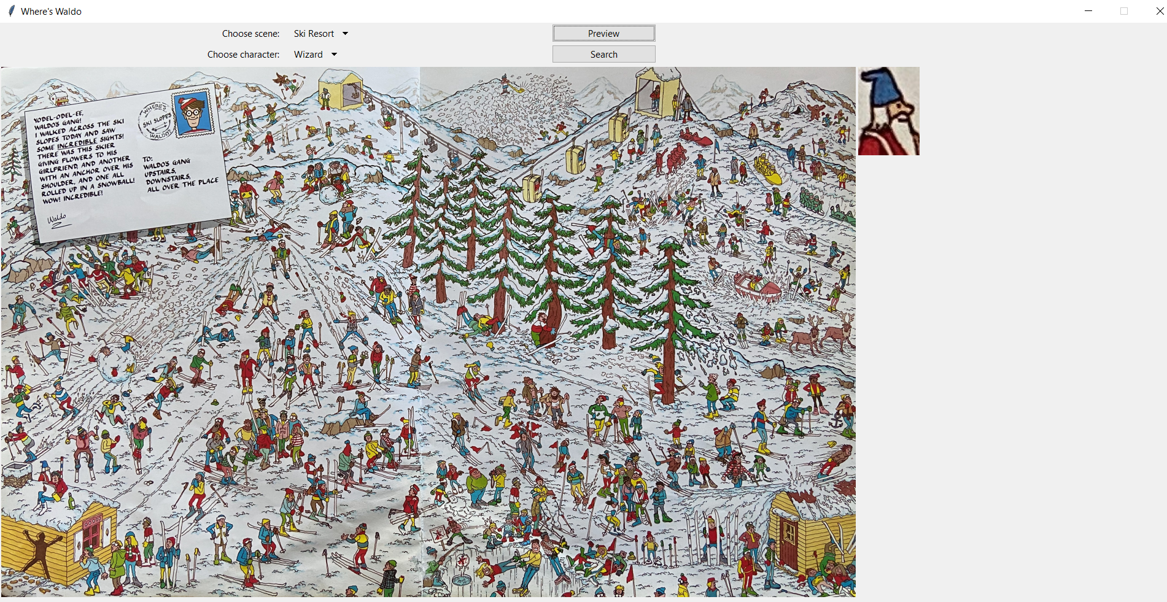

Choose a new scene (Ski Resort) and new character (Wizard), then click “Preview” to get to the screenshot above.

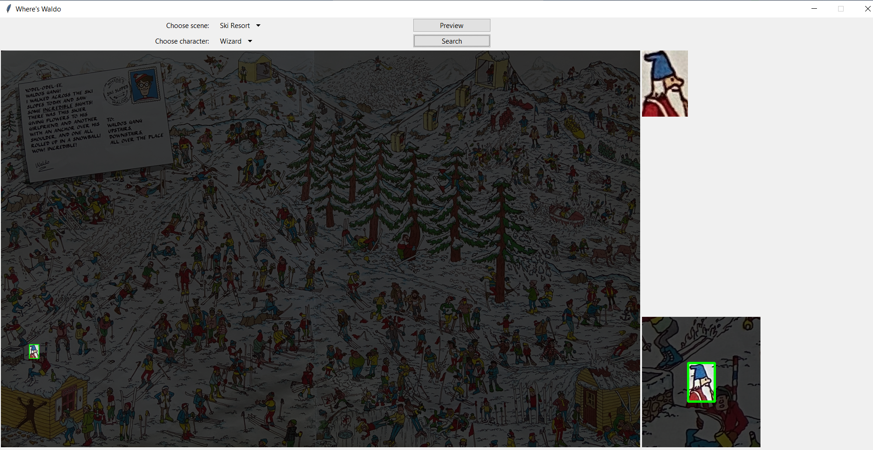

Click “Search” to find Wizard in the Ski Resort scene.

The program finds the user selected Where’s Waldo character within the chosen Where’s Waldo puzzle image according to the test matrix below:

|  |  |  |  |
| --- | --- | --- | --- |
|  | **City** | **Zoo** | **Ski Resort** |
| **Waldo** | Found | Found | Not Found |
| **Wenda** | Found | Found | Found |
| **Wizard** | Found | Found | Found |
| **Odlaw** | Not Found | Found | Found |
| **Woof** | Not Found | Not Found | Not Found |

*Note: In each case where the chosen character was found, the 10-second performance estimate threshold was met.